* Hold 1 18 21
* With or condition
* Fileaid searching with hexa value in unformatted mode

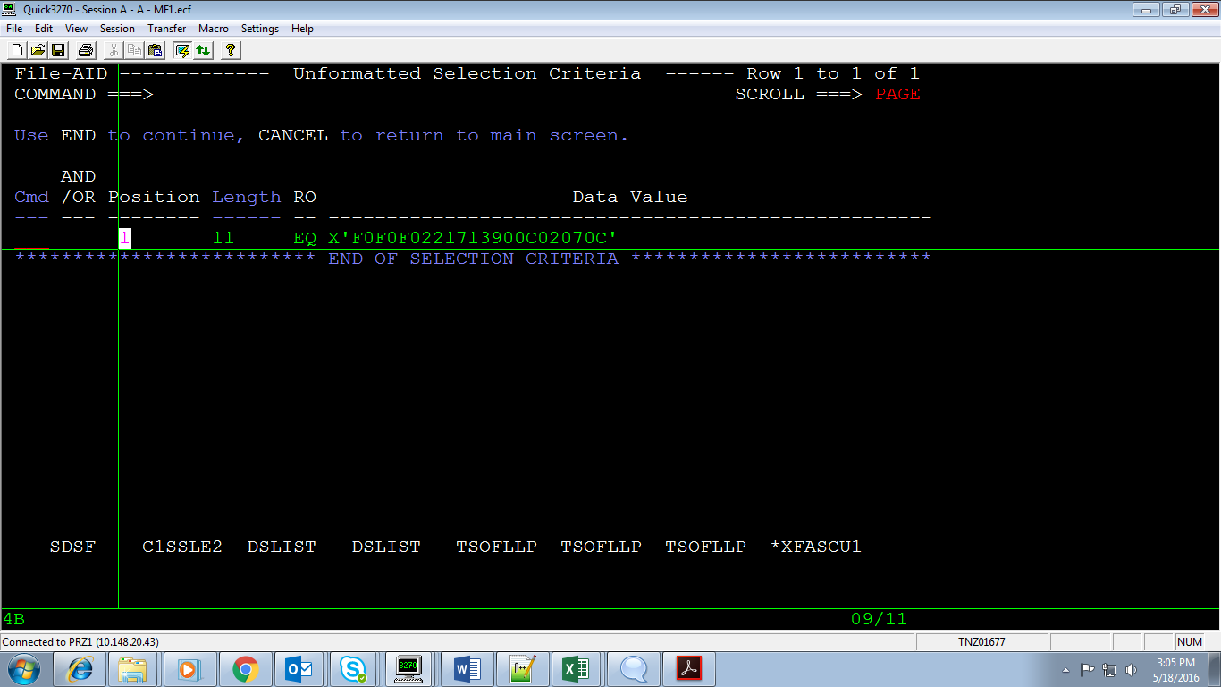

* Change all option in fileaid

Go to 3.6

Then give PDS name then option M

Now to change all use C “var1” “change var”

To find variable use F “var1”